Project: LightBulbs

Author: Tomás Lucas Vilaboa

Hours: 9

Code Lines: 285

Files: Main.c, tree.h,list.h,lightbulb.h

***UML***

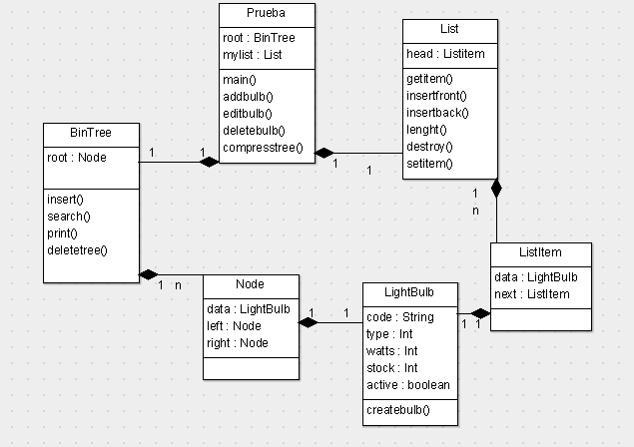

***Main.c***

#include<stdlib.h>

#include<stdio.h>

#include "lightbulb.h"

#include "List.h"

#include "tree.h"

//loads a list ,to load the list u want,code must be modified to create o import that list here

void main()

{

node *root;

List mylist;

initlist(&mylist);

root = NULL;

int n=length(mylist);

int i=0;

for(i;i<n;i++){

insert(&root,getitem(mylist,i));

}

int menu;

do{printf("\n\n1- Add lightbulb \n2- Delete lightbulb \n3- Edit lightbulb \n4- Print tree\n5- Compress tree\n\n");

scanf("%d",&menu);

switch(menu){

case 1: addbulb(&root); break;

case 2: deletebulb(root); break;

case 3: editbulb(root);break;

case 4: printtree(root);break;

case 5: compresstree(root);break;

}}

while(menu<6);

}

void addbulb(node ** root){

struct lightbulb bulb;

createBulb(&bulb);

insert(root, bulb);

}

void deletebulb(node * root){

struct lightbulb find;

createBulb(&find);

node *tmp;

tmp = search(&root, find);

if (tmp)

{

tmp->data.active=0;

printf("Data succesfully deleted.\n");

}

else

{

printf("Data Not found in tree.\n");

}

}

void editbulb(node * root){

struct lightbulb find;

createBulb(&find);

node *tmp;

tmp = search(&root, find);

if (tmp)

{

printf("\nInsert new values\n");

createBulb(&root->data);

printf("Data succesfully edited.\n");

}

else

{

printf("Data Not found in tree.\n");

}

}

void printtree(node *root){

printf("Pre Order Display\n");

print_preorder(root);

printf("In Order Display\n");

print_inorder(root);

printf("Post Order Display\n");

print_postorder(root);

}

//compress tree,deletion is implemented in logical way, so tree must be compressed in order to really free the memory

void compresstree(node *root){

node *newroot;

newroot=NULL;

compress(root,newroot);

root=newroot;

}

void compress(node *tree,node *newroot){

if (tree)

{

insert(&newroot,tree->data);

compress(tree->left,newroot);

compress(tree->right,newroot);

}

}

***Tree.h***

struct bin_tree {

struct lightbulb data;

struct bin_tree * right, * left;

};

typedef struct bin_tree node;

void insert(node ** tree, struct lightbulb val)

{

node *temp = NULL;

if(!(*tree))

{

temp = (node *)malloc(sizeof(node));

temp->left = temp->right = NULL;

temp->data = val;

*tree = temp;

return;

}

if(val.type < (*tree)->data.type)

{

insert(&(*tree)->left, val);

}

else if(val.type > (*tree)->data.type)

{

insert(&(*tree)->right, val);

}

}

void print_preorder(node * tree)

{

if (tree)

{

printlightBulb(tree);

print_preorder(tree->left);

print_preorder(tree->right);

}

}

void print_inorder(node * tree)

{

if (tree)

{

print_inorder(tree->left);

printlightBulb(tree);

print_inorder(tree->right);

}

}

void print_postorder(node * tree)

{

if (tree)

{

print_postorder(tree->left);

print_postorder(tree->right);

printlightBulb(tree);

}

}

void printlightBulb(node * tree){

if(tree->data.active==1){

printf("\nCode:%s\n",tree->data.code);

printf("Watts:%d\n",tree->data.watts);

printf("Type:%d\n",tree->data.type);

printf("Stock:%d\n\n",tree->data.cant);

}

}

void deltree(node * tree)

{

if (tree)

{

deltree(tree->left);

deltree(tree->right);

free(tree);

}

}

//search and return a lightbulb

node* search(node ** tree, struct lightbulb val)

{

if(!(*tree))

{

return NULL;

}

if(val.type < (*tree)->data.type)

{

search(&((*tree)->left), val);

}

else if(val.type > (*tree)->data.type)

{

search(&((*tree)->right), val);

}

else if(val.type == (*tree)->data.type)

{

return *tree;

}

}

***List.h***

#ifndef _LIST_H

#define _LIST_H

struct listitem {

struct lightbulb data;

struct listitem *next;

};

typedef struct listitem Listitem;

struct list {

Listitem *head;

};

typedef struct list List;

void initlist (List *); /* initialize an empty list */

void insertfront(List * , struct lightbulb val); /* insert val at front */

void insertback(List *, struct lightbulb val); /* insert val at back */

int length(List); /* returns list length */

void destroy(List *); /* deletes list */

void setitem(List *, int n, struct lightbulb val);/* modifies item at n to val*/

struct lightbulb getitem(List, int n); /* returns value at n*/

#endif /* _LIST_H */

void initlist(List *ilist) {

ilist->head = 0;

}

void insertfront(List *ilist, struct lightbulb val) {

Listitem *newitem;

newitem = (Listitem *)malloc(sizeof(Listitem));

newitem->next = ilist->head;

newitem->data = val;

ilist->head = newitem;

}

void insertback(List *ilist, struct lightbulb val) {

Listitem *ptr;

Listitem *newitem;

newitem = (Listitem *)malloc(sizeof(Listitem));

newitem->data = val;

newitem->next = 0;

if (!ilist->head) {

ilist->head = newitem;

return;

}

ptr = ilist->head;

while (ptr->next)

{

ptr = ptr->next;

}

ptr->next = newitem;

}

int length(List ilist){ /* returns list length */

Listitem *ptr;

int count = 1;

if (!ilist.head) return 0;

ptr = ilist.head;

while (ptr->next) {

ptr = ptr->next;

count++;

}

return count;

}

void destroy(List *ilist) { /* deletes list */

Listitem *ptr1,*ptr2;

if (!ilist->head) return; /* nothing to destroy */

ptr1 = ilist->head; /* destroy one by one */

while (ptr1) {

ptr2 = ptr1;

ptr1 = ptr1->next;

free(ptr2);

}

ilist->head = 0;

}

void setitem(List *ilist, int n, struct lightbulb val){

/* modifies a value*/

/* assume length is at least n long */

Listitem *ptr;

int count = 0;

if (!ilist->head) return;

ptr = ilist->head;

for (count = 0;count < n;count ++)

{

if (ptr) ptr = ptr->next;

else return;

}

if (ptr)

ptr->data = val;

}

struct lightbulb getitem(List ilist, int n) {

/* returns a list value,

* assume length is at least n long */

Listitem *ptr;

int count = 0;

ptr = ilist.head;

if (n==0) return ptr->data;

while (ptr->next) {

ptr = ptr->next;

count++;

if (n == count)

return (ptr->data);

}

}

***LightBulb.h***

struct lightbulb{

char code[5];

int watts;

int type;

int cant;

int active; //deletion is implemented in logical way

} ;

void createBulb(struct lightbulb *bulb){

printf("Enter lightbulb code (max 5 chars). \n");

scanf("%s",bulb->code);

printf("Enter lightbulb watts.\n");

scanf("%d",&bulb->watts);

printf("Enter lightbulb type. \n");

scanf("%d",&bulb->type);

printf("Enter lightbulb stock. \n");

scanf("%d",&bulb->cant);

bulb->active=1;

}